Current Operable Unit 3 Remedial Progress for Phase II Week Ending 6/25/10
Creamer Environmental Inc., National Grid’s Remediation Contractor, has completed 4 out of 4 cells thus completing Phase II of the project. To date 106 trucks have transported 3178.11 tons of soil to Bay Shore Soil Management (BSSM, formerly ESMI of NJ) for thermal desorption. Additionally 126,664 gallons of impacted excavation water has been disposed of at Clean Waters of Staten Island. Site restoration activities are anticipated to be completed by week ending June 25, 2010.
GEI, National Grid’s Remediation Oversight Consultant, will continue to perform CAMP (Community Air Monitoring Program) and Noise and Vibration monitoring. CAMP and Noise and Vibration monitoring will end approximately June 25, 2010.
General hours of operation will continue to be Monday through Friday, 7:00 AM to 3:30 PM. However, work hours will be extended when necessary to maintain schedule or to complete critical tasks.
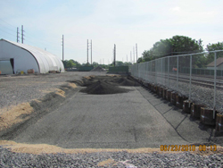
installing final layer of compacted back fill
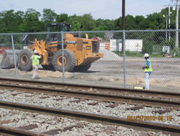
CEI conducting compaction testing
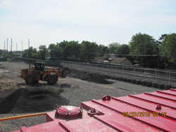
CEI installing backfill material

